Document for angular app with backend nondejs and xampp server for creating users and displaying stored users.   
================================================================================

The below screen shot for xampp server

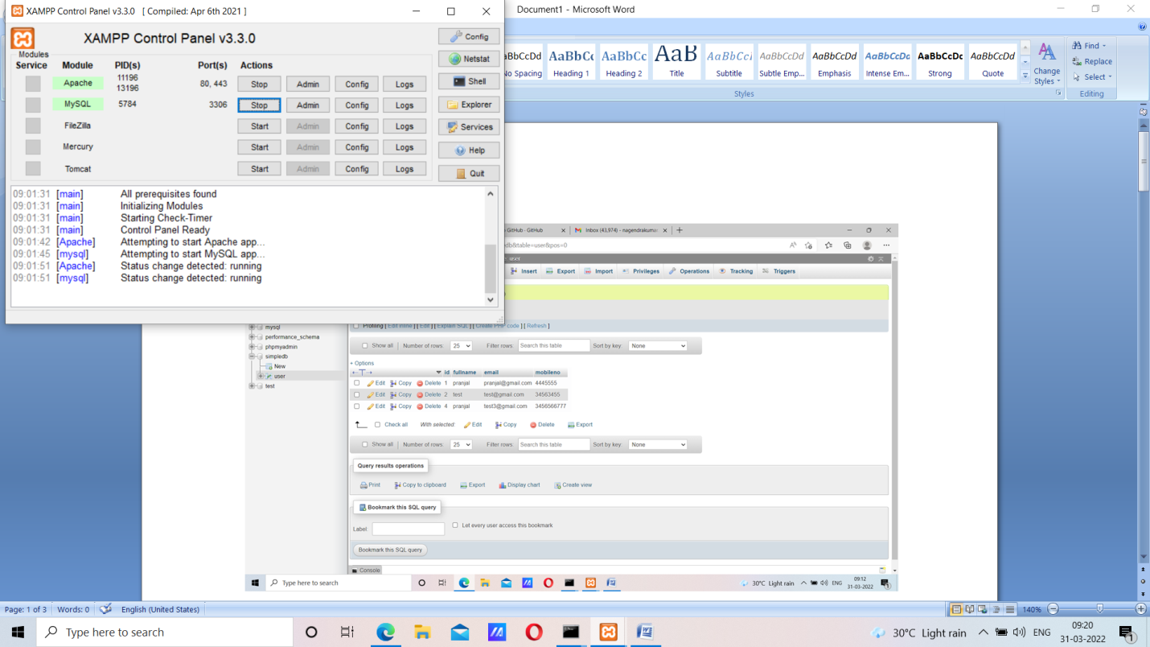

The below screen shot for database and usertable

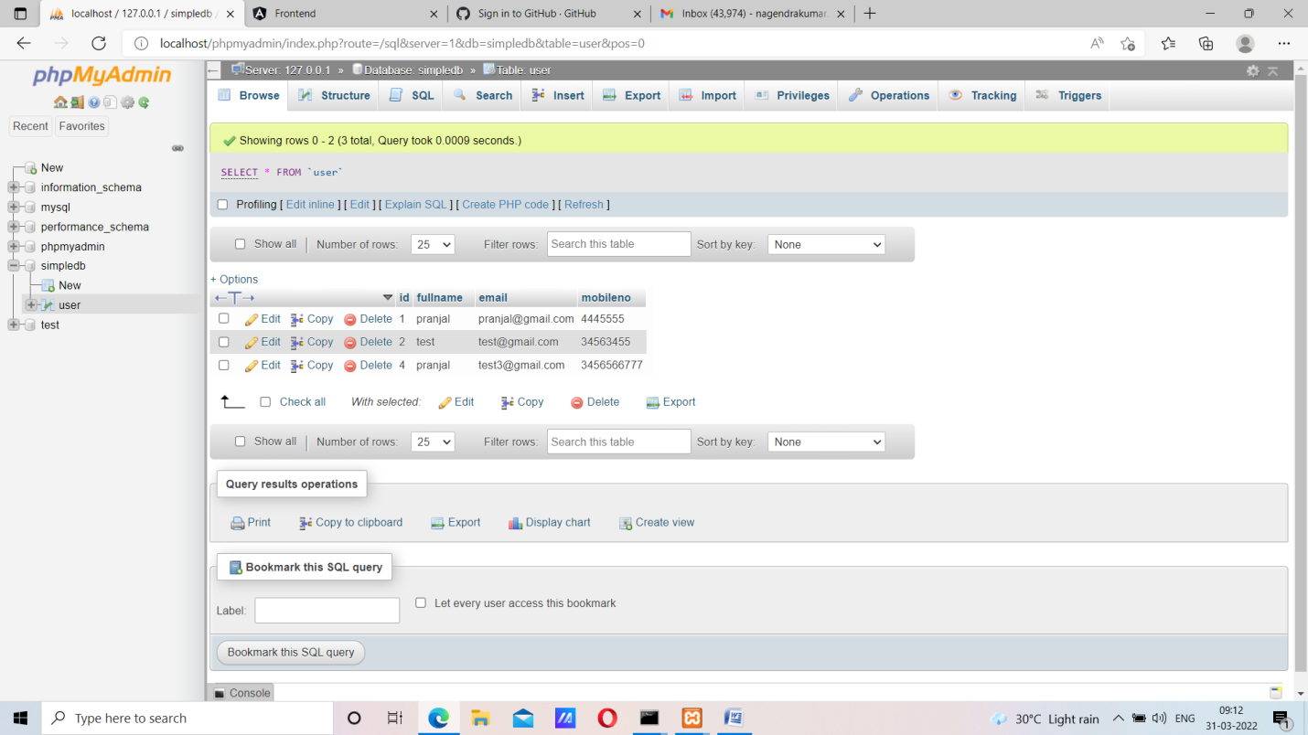

The below screenshot for front end app showing two tabs create and read for user data.

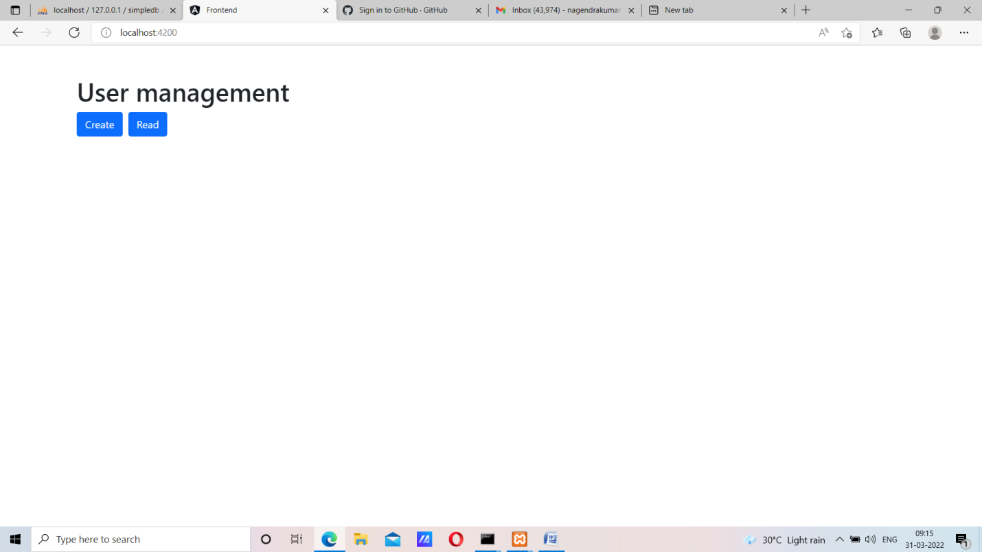

Below screenshot for user creation using creation form

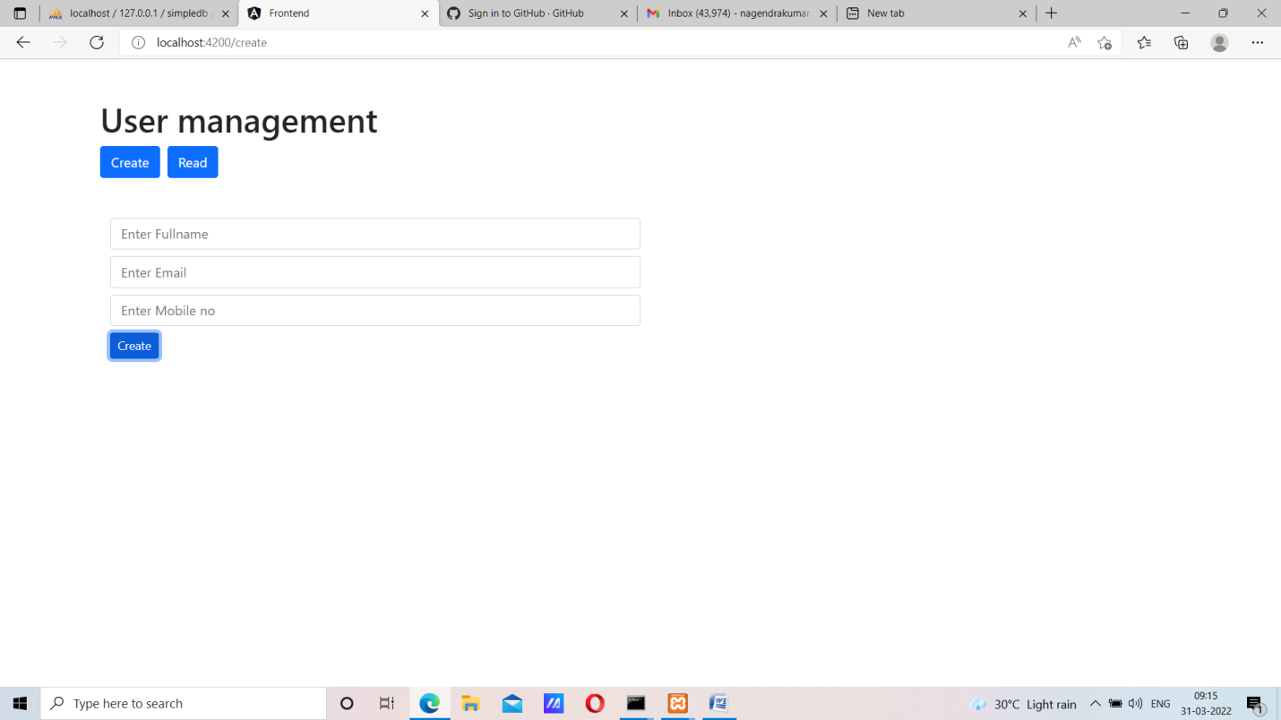

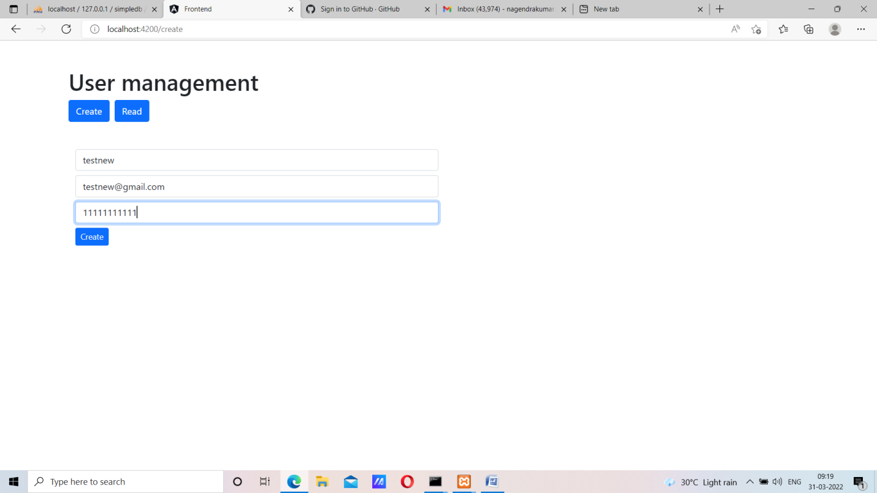

The below screenshot for user data what ever stored in database.

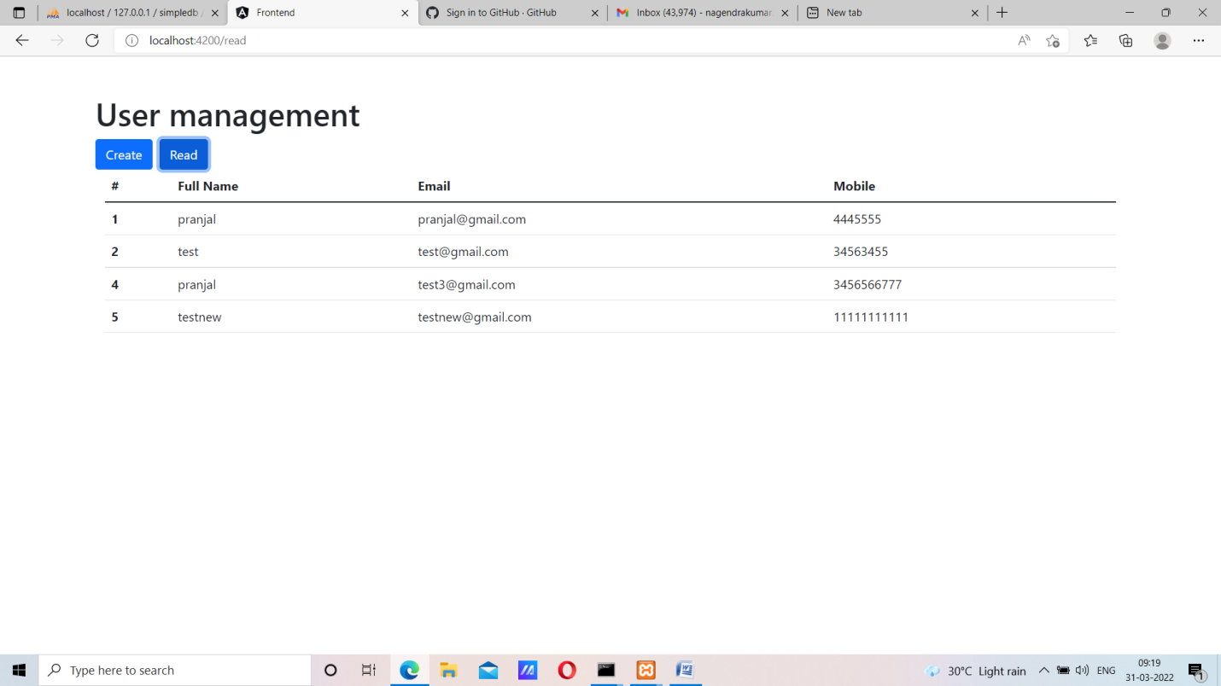

The below screen shot for users updated data stored in database.

